TAMS Standard HydInfra Reports 5/21/18
TAMS reports are very flexible to use to list, summarize and export TAMS data. All TAMs HydInfra users should have access to the TAMS inventory and inspection data in order to report on. The filter can be set to just return data that is needed.
Template reports are available in the public folder for TAMS HydInfra inventory and inspections. These template reports have some preset filters that you will need to customize for your needs. You can copy these reports into your reports folder and then customize for what you need.
Report Name | Filters - Select appropriate values for Filters in Bold | Report Description
Pipe Condition along Road | Status = Inplace, Proposed  Administrative Unit (District)  Route Number  BMP (Begin Mile Point) | Highest priority inventory and inspection data for scoping and inspection review
Pipe Inventory Inspection All Data | Status = Inplace, Proposed  Administrative Unit (District)  Route Number  BMP (Begin Mile Point) | All inventory and inspection data for pipes in same order as inventory and inspection windows
Structure-Spec Feature Inventory-Inspection All Data | Status = Inplace, Proposed  Class Code = Structure and Special Feature  Administrative Unit (District)  Route Number  BMP (Begin Mile Point) | All inventory and inspection data for pipes in same order as inventory and inspection windows
SPCD Inventory-Inspection All Data | Status = Inplace, Proposed  Class Code = SPCD  Administrative Unit (District) | All inventory and inspection data for pipes in same order as inventory and inspection windows
Pond-Basin Inventory-Inspection All Data | Status = Inplace, Proposed  Administrative Unit (District) | All inventory and inspection data for pipes in same order as inventory and inspection windows
HYD_PIPE_SUMMARY AGGREGATE EXAMPLE | Status = Inplace, Proposed | Template for doing aggradation/summary on specific fields

Below are some limited instructions on accessing and updating the TAMS HydInfra template reports. More details on using reports are in the user manuals you received at training. These manuals are also available on the TAMS HydInfra support web page.

Procedure to Access and Use:
- Go to TAMS Reports window
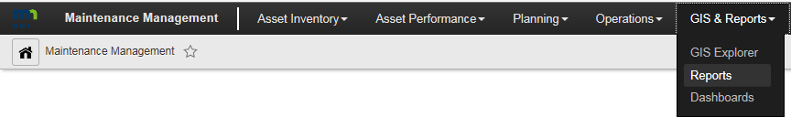

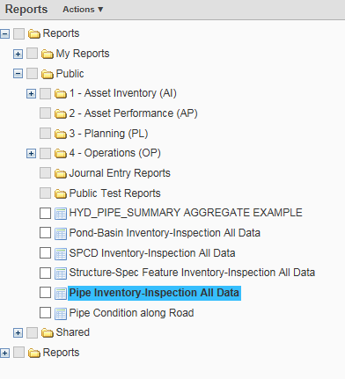
- Expand Public folder

These reports are under Public for now, expect that AMPO office will set up folder under Asset Inventory specifically for TAMS HydInfra reports at some point)

If one-time report, can just use Public report, but will not be able to save. In general, copy/paste the report under your folder so that you can save common filters, update and re-use.

- Copy and Paste report into My Reports folder
  - Right click on desire report and select Copy
  - Select My Reports, right click and select Paste
If you are using the HydInfra Viewer role, you will be able to save copies of the Standard Template Reports and update the filter/fields, but not able to rename

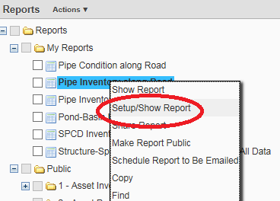
- Right click on report to run/update and select Setup/Show Report. For all of the template reports, you will need to select appropriate parameters at least the first time you run. For reports that you run along a road segment, you will need to go through the setup to update the road segment information.

- Update Filter to set parameters.
  - Select Filter button when get to Setup Window
  - Administrative Unit (District) – Toggle off or scroll down in right window to select correct district.
    - If you are showing features along a roadway segment, better to just toggle Administrative Unit off
  - Route Number – Type in road system and road number following format MN36, US10, I35
    - If not sure of format, run report for entire district first and see the values that are used
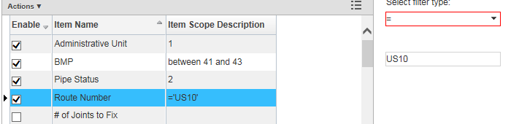
  - BMP – Begin Measure Point
    - Enter the beginning and ending measure point. This is not exactly the same as reference point – recommend that you include a buffer on the beginning and end and review against aerial photos to see if have included all of desired stretch of road
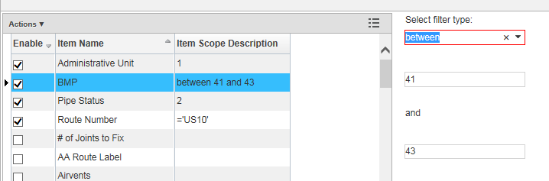

  - Pipe Status – default set to Inplace and Proposed. Generally do not need to reset
  - Click on OK button

- Click on Show Report button

Hints:
BMP – Begin Measure Point in TAMS is based on the CARTO measurement in LRS. You can estimate to/from Reference Post/Offset using the Roadway Project Mapping Application (RPMA)
Year to Inspect is calculated for Highway Culverts based on the Performance measurements. If you use a filter to find Highway Culverts due for an inspection, make sure to use <= as the operator. If pipe is past due for an inspection, than the year inspection was first due is the value in this field.
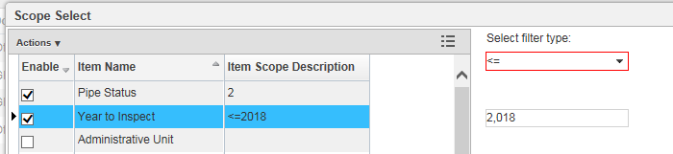

MS4 Area field in Reports is same as Report MS4 field in inventory window. This field is used to select Pipe and Structure Outfalls, SPCDs and Ponds where MnDOT is required by permit to report to MPCA on inspections. All of Metro District is included for report. For other districts, just urbanized areas (as determined by census rules) for Duluth, St. Cloud, Grand Forks, Fargo, Mankato, Rochester and La Crosse. Contact Tara Carson for more information on the requirements and boundaries.

